Shrinkage correlation: GBPUSD and AUDUSD
Method 08 / eight-major panel / delta = 0.2 and Ledoit-Wolf / Alpari D1 full available history

Study setup
Logical pair: GBPUSD , AUDUSD
Broker symbols: GBPUSD_i , AUDUSD_i
Snapshot: 2026-11-03_majors_alpari_D1
Timeframe: D1
Common eight-major panel window: 1999-01-06 to 2026-11-02 (UTC bar dates)
Panel matched return count n: 7127
Dropped unfinished last bar dated 2026-11-03 UTC after a tick-volume check against the prior complete day.
Fixed shrinkage: delta=0.2, mu=3.9170889e-05 (mean of diag(S))
Ledoit-Wolf estimated delta: 0.0042157642
Panel symbols: EURUSD, GBPUSD, AUDUSD, NZDUSD, USDJPY, USDCHF, USDCAD, EURGBP
Complete matched rows (Excel): GBPUSD-AUDUSD_Shrinkage_D1.xlsx
Complete matched rows (HTML table): GBPUSD-AUDUSD_Shrinkage_D1_data.html

Method carried forward
Shrinkage blends the sample covariance matrix S of matched daily log returns of close, ln(close_t / close_t-1), toward a simple target, then converts the shrunk covariance into correlations. Quotes are not inverted. This experiment builds one common calendar across all eight majors, forms S with the unbiased n-1 divisor, then reports two shrinkage specs: fixed delta = 0.2 with mu equal to the average sample variance (mu * I target), and sklearn Ledoit-Wolf with its estimated delta. Pair reports pull rho_ij from those panel matrices. Same-panel Pearson r is a side check only. Shrinkage improves conditioning; it is not a cause, not a lead, and not a trading signal.

Results
pearson_r | rho_02 | rho_LW | rho_02_minus_r | rho_LW_minus_r | delta_LW
0.54079 | 0.437012 | 0.538608 | -0.103778 | -0.002183 | 0.00421576

Conclusion
Over the common 7127-day eight-major panel for GBPUSD and AUDUSD (broker quote directions unchanged), fixed-delta shrinkage correlation at delta=0.2 is 0.4370 (positive, moderate linear link in this sample). Ledoit-Wolf rho is 0.5386 with estimated delta=0.004216. Same-panel Pearson r is 0.5408 (rho_02 minus r = -0.1038; rho_LW minus r = -0.0022). This does not establish cause, lead-lag, or a lasting trading rule.

Charts
Daily closes
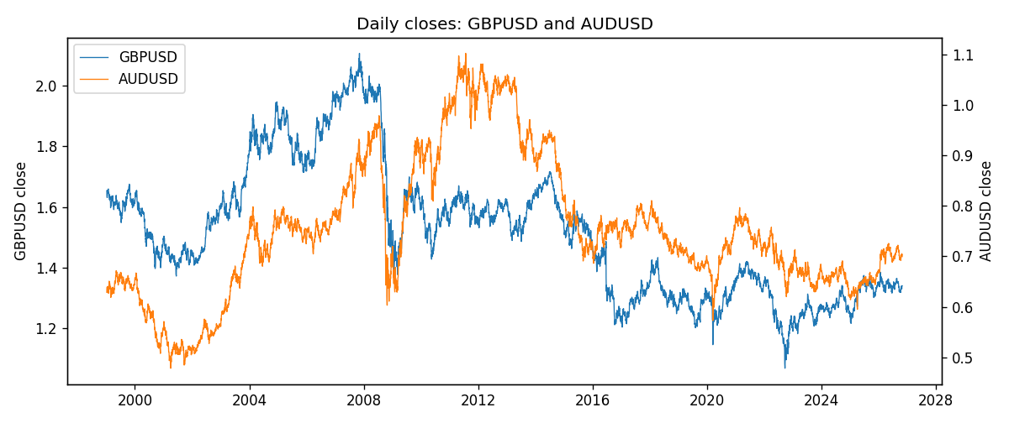
Daily log returns
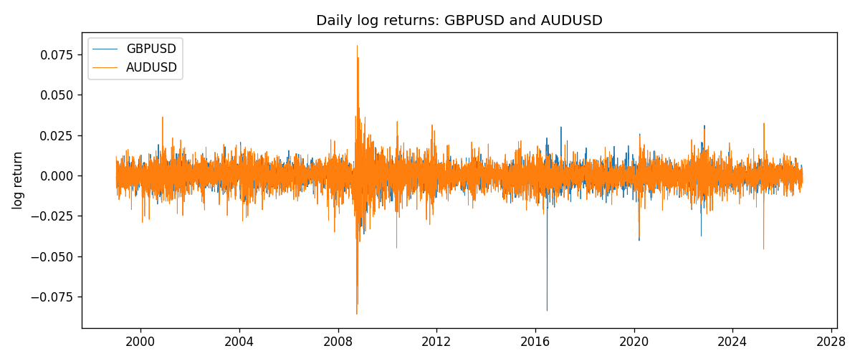
Log-return scatter
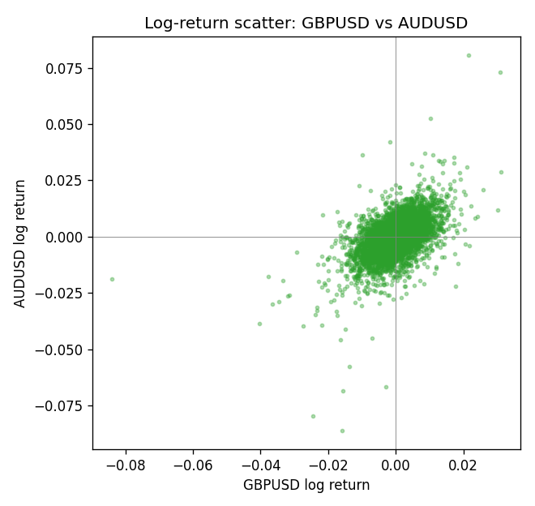

Data report
Every panel row for this pair slice is stored in the sibling Excel workbook named GBPUSD-AUDUSD_Shrinkage_D1.xlsx. Full-panel covariance and correlation matrices are saved once under outputs/ as CSV files. Embedding all rows as a Word table is impractical at this length; the Word file holds the column list, column summaries, and the first and last 15 matched rows.
Columns: time, GBPUSD_open, GBPUSD_high, GBPUSD_low, GBPUSD_close, GBPUSD_tick_volume, GBPUSD_spread, GBPUSD_real_volume, GBPUSD_log_return, AUDUSD_open, AUDUSD_high, AUDUSD_low, AUDUSD_close, AUDUSD_tick_volume, AUDUSD_spread, AUDUSD_real_volume, AUDUSD_log_return
Column summaries (panel rows)
column | count | mean | std | min | 25% | 50% | 75% | max
GBPUSD_open | 7127 | 1.5143204 | 0.21800183 | 1.06854 | 1.323655 | 1.5093 | 1.62967 | 2.1066
GBPUSD_high | 7127 | 1.5206136 | 0.21856742 | 1.08366 | 1.32882 | 1.5159 | 1.636975 | 2.1161
GBPUSD_low | 7127 | 1.508003 | 0.21722806 | 1.03518 | 1.3185 | 1.501 | 1.623 | 2.0983
GBPUSD_close | 7127 | 1.5143843 | 0.21795834 | 1.06879 | 1.32373 | 1.5095 | 1.62965 | 2.1065
GBPUSD_tick_volume | 7127 | 95725.777 | 154086.85 | 62 | 10131.5 | 53562 | 92170 | 1273370
GBPUSD_spread | 7127 | 26.790936 | 19.185969 | 0 | 10 | 20 | 50 | 50
GBPUSD_real_volume | 7127 | 3.5930129e+09 | 8.4874724e+10 | 0 | 0 | 0 | 0 | 2.4038164e+12
GBPUSD_log_return | 7127 | -2.548e-05 | 0.00564718 | -0.08388241 | -0.00312586 | 3.034e-05 | 0.00318105 | 0.03112653
AUDUSD_open | 7127 | 0.75283275 | 0.13531386 | 0.4785 | 0.66158 | 0.7319 | 0.812805 | 1.10284
AUDUSD_high | 7127 | 0.75689359 | 0.13587198 | 0.4878 | 0.66567 | 0.73555 | 0.8193 | 1.10795
AUDUSD_low | 7127 | 0.74877471 | 0.1346251 | 0.4775 | 0.65837 | 0.72811 | 0.80713 | 1.0975
AUDUSD_close | 7127 | 0.75288849 | 0.13529323 | 0.4786 | 0.661725 | 0.7321 | 0.812865 | 1.10169
AUDUSD_tick_volume | 7127 | 78106.737 | 138648.75 | 109 | 5647 | 44017 | 71744.5 | 1234623
AUDUSD_spread | 7127 | 30.658622 | 16.888951 | 0 | 13 | 30 | 50 | 50
AUDUSD_real_volume | 7127 | 5.2965195e+09 | 1.2602867e+11 | 0 | 0 | 0 | 0 | 3.811512e+12
AUDUSD_log_return | 7127 | 3.23e-05 | 0.0075548 | -0.08602525 | -0.00385041 | 0.00029027 | 0.00415332 | 0.0806166
First 15 panel rows (selected columns)
time | GBPUSD_close | AUDUSD_close | GBPUSD_log_return | AUDUSD_log_return
1999-01-06 | 1.6537 | 0.6289 | -0.00060452184 | 0.011836351
1999-01-07 | 1.6502 | 0.6345 | -0.002118709 | 0.0088650256
1999-01-08 | 1.6405 | 0.6347 | -0.0058954193 | 0.00031515916
1999-01-11 | 1.6312 | 0.6393 | -0.0056851331 | 0.0072213815
1999-01-12 | 1.6349 | 0.6362 | 0.0022657001 | -0.0048608485
1999-01-13 | 1.6499 | 0.6312 | 0.0091330396 | -0.0078902098
1999-01-14 | 1.6531 | 0.6295 | 0.0019376331 | -0.002696916
1999-01-15 | 1.6502 | 0.634 | -0.0017558204 | 0.007123101
1999-01-18 | 1.6522 | 0.6346 | 0.0012112405 | 0.00094592471
1999-01-19 | 1.6553 | 0.6392 | 0.0018745281 | 0.0072225153
1999-01-20 | 1.6472 | 0.64 | -0.0049053846 | 0.0012507819
1999-01-21 | 1.6524 | 0.6405 | 0.0031518998 | 0.00078094498
1999-01-22 | 1.6565 | 0.6327 | 0.0024781662 | -0.012252745
1999-01-25 | 1.6585 | 0.6302 | 0.0012066366 | -0.0039591468
1999-01-26 | 1.6597 | 0.6305 | 0.00072328374 | 0.00047592608
Last 15 panel rows (selected columns)
time | GBPUSD_close | AUDUSD_close | GBPUSD_log_return | AUDUSD_log_return
2026-10-13 | 1.32534 | 0.69821 | 0.0036434319 | 0.0035007712
2026-10-14 | 1.31884 | 0.69715 | -0.0049164679 | -0.0015193215
2026-10-15 | 1.32757 | 0.69191 | 0.0065976411 | -0.0075447063
2026-10-16 | 1.33257 | 0.69426 | 0.0037592051 | 0.0033906408
2026-10-19 | 1.33024 | 0.6978 | -0.0017500314 | 0.0050859986
2026-10-20 | 1.3377 | 0.70022 | 0.0055923442 | 0.0034620426
2026-10-21 | 1.33937 | 0.70275 | 0.0012476328 | 0.0036066384
2026-10-22 | 1.33967 | 0.70186 | 0.00022396082 | -0.0012672558
2026-10-23 | 1.33684 | 0.70353 | -0.0021146949 | 0.0023765656
2026-10-26 | 1.33359 | 0.70128 | -0.0024340661 | -0.0032032829
2026-10-27 | 1.33044 | 0.70245 | -0.0023648393 | 0.0016669876
2026-10-28 | 1.33254 | 0.70533 | 0.0015771808 | 0.0040915541
2026-10-29 | 1.33733 | 0.70245 | 0.0035881935 | -0.0040915541
2026-10-30 | 1.33913 | 0.70316 | 0.0013450605 | 0.0010102376
2026-11-02 | 1.3406 | 0.69971 | 0.0010971256 | -0.0049184984

